**The findings were generated using SQL queries, and the detailed results are attached**

1.Total revenue

sum of the total price of all the pizza orders

select sum(total_price) as Total_Revenue

from [dbo].[ PizzaSales]

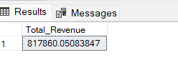

2.Total Pizza sold

Sum of the quantities of all the pizzas sold

select sum(quantity) as total_pizza_sold

from [dbo].[ PizzaSales]

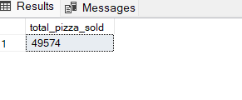

3.Total Orders

The total number of orders

select count( distinct order_id) as total_orders

from [dbo].[ PizzaSales]

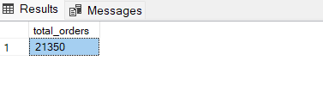

4.Average pizzas per order

The average number of pizzas sold per order, calculated by dividing the total number of pizzas sold by the total number of orders

select cast(sum (quantity) as decimal(10,2))/

count ( distinct order_id)

from [dbo].[ PizzaSales]

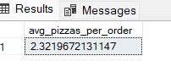

5.Daily trend of total orders

select DATENAME(dw,order_date) as order_day,count(distinct order_id)as total_orders

from [dbo].[ PizzaSales]

group by DATENAME(dw,order_date)

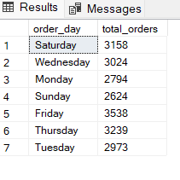

6.monthly trend of total orders

select DATENAME(month,order_date) as month_name,count(distinct order_id)as total_orders

from [dbo].[ PizzaSales]

group by DATENAME(month,order_date)

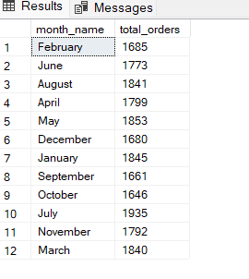

7.Percentage of sales by pizza category

select pizza_size,sum(total_price) as total_sales,sum(total_price) *100 /

(select sum(total_price) from [dbo].[ PizzaSales]) as pct

from [dbo].[ PizzaSales] as total_sales

group by pizza_size

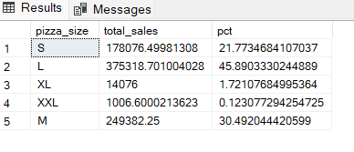

8.Top 5 best sellers by revenue

select top 5 pizza_name,sum(total_price) as total_revenue

from [dbo].[ PizzaSales]

group by pizza_name

order by total_revenue desc

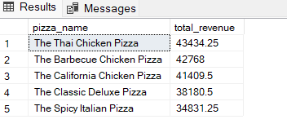

9.Least 5 sellers by revenue

select top 5 pizza_name,sum(total_price) as total_revenue

from [dbo].[ PizzaSales]

group by pizza_name

order by total_revenue asc

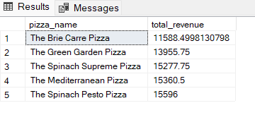

10.Best selling pizza by quantity vice

select top 5 pizza_name,sum(quantity) as total_quantity

from [dbo].[ PizzaSales]

group by pizza_name

order by total_quantity desc

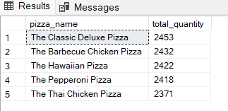

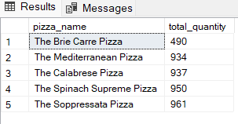

11.Least selling pizza quantity vice

select top 5 pizza_name,sum(quantity) as total_quantity

from [dbo].[ PizzaSales]

group by pizza_name

order by total_quantity asc

